* Welcome page “**Online Food order Application**”. Page having search button to search the food as well have all available food button option.

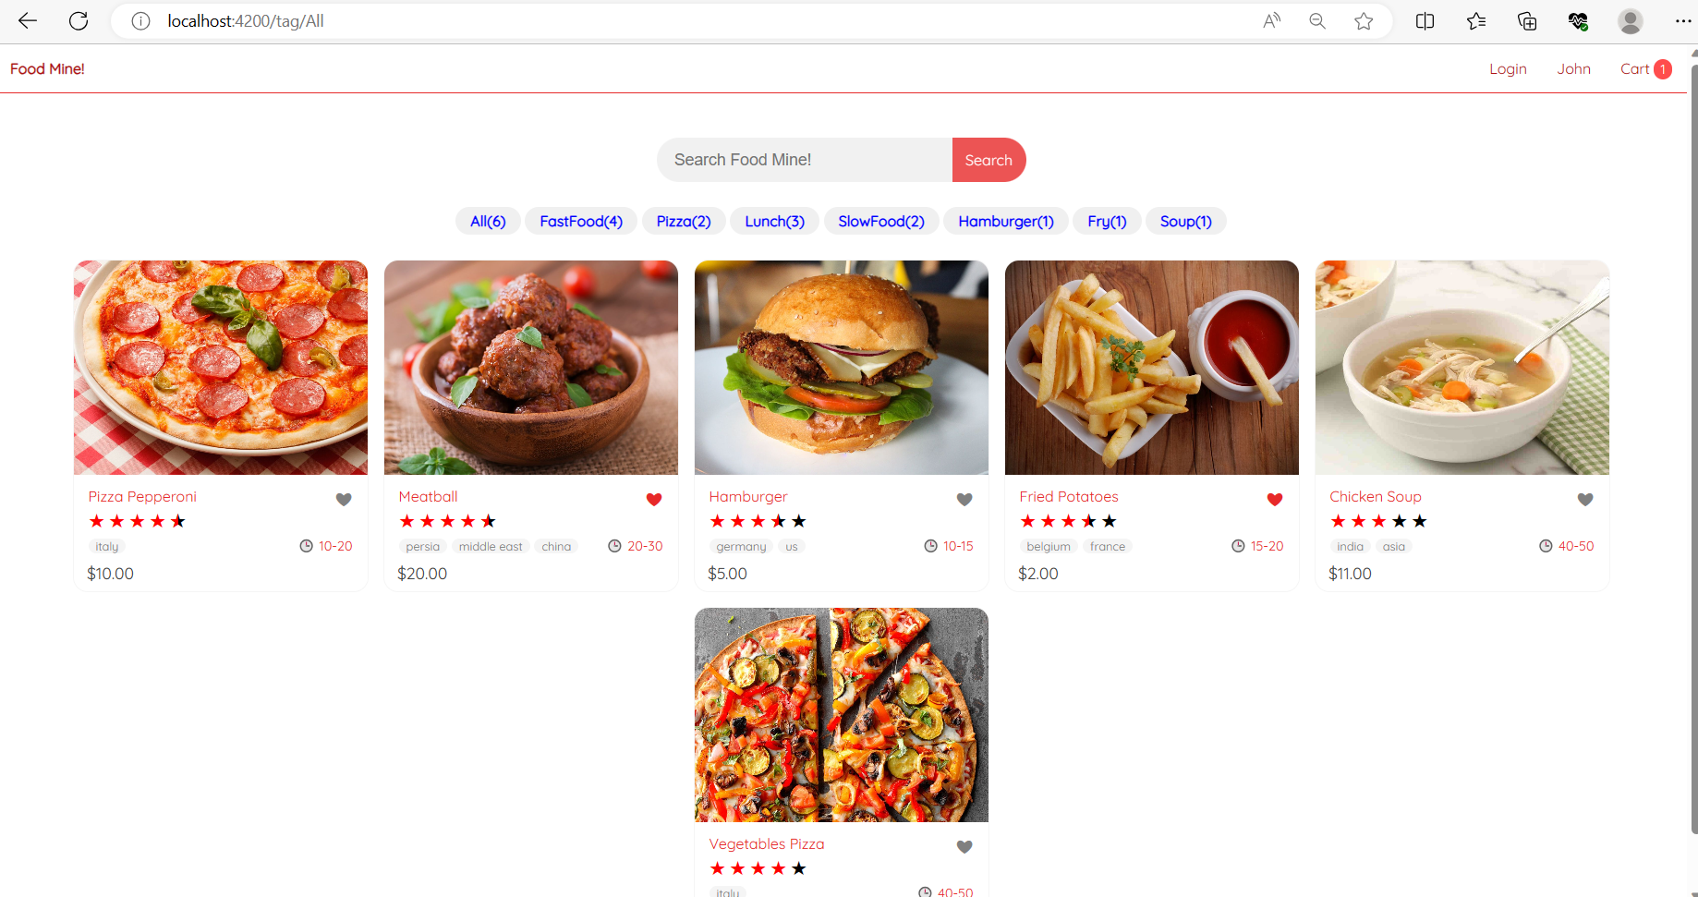

* My application has 8 button of food and having 7 categories:
* All food
* Fast Food
* Pizza
* Lunch
* Slow Food
* Hamburger
* Fry
* Shop

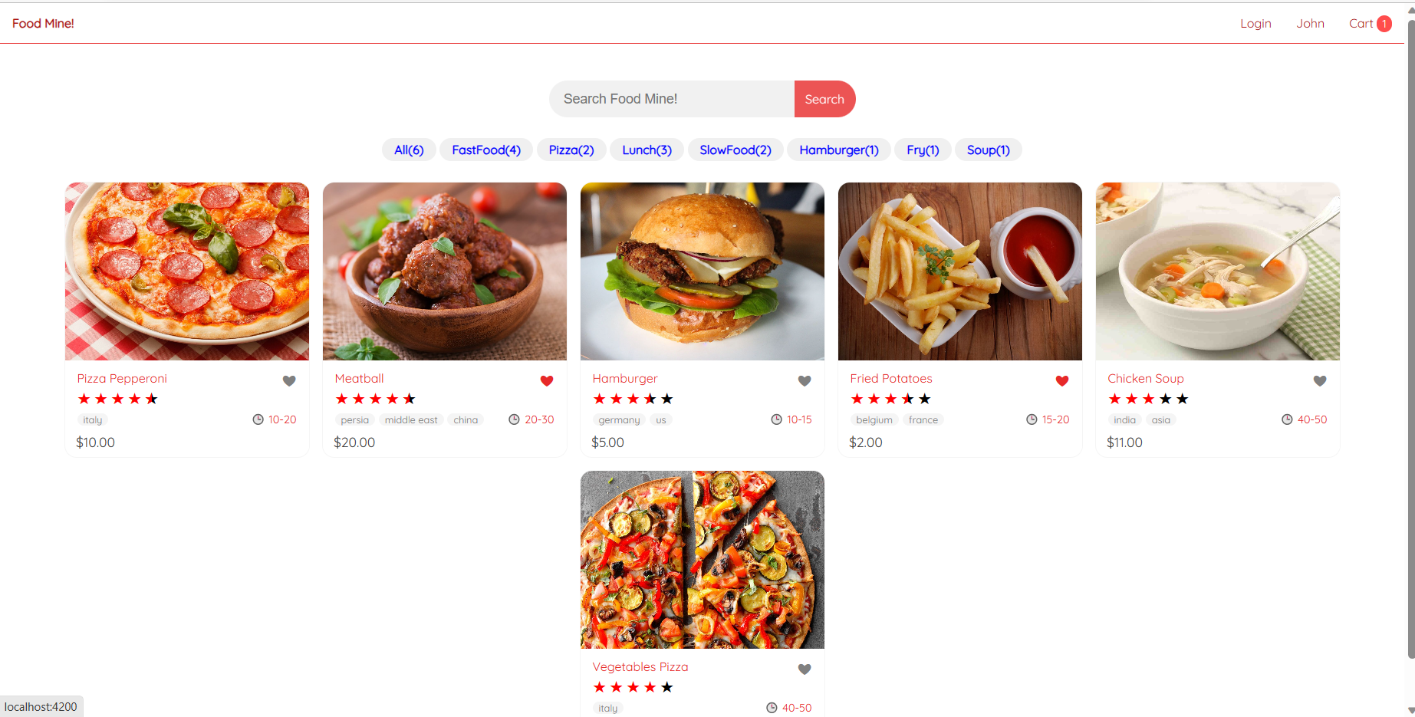

* If you clicked on Fast food, it will show you below page

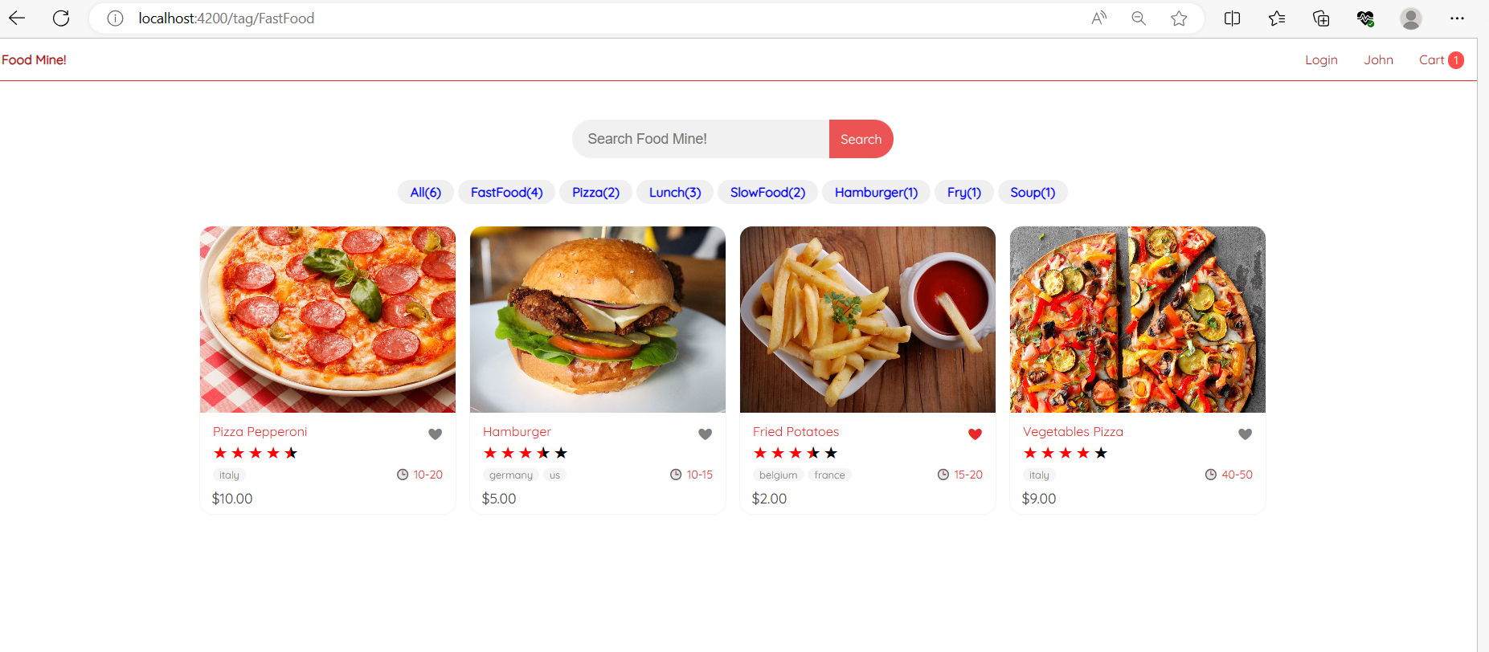

* If you clicked on Pizza, it will show you below page

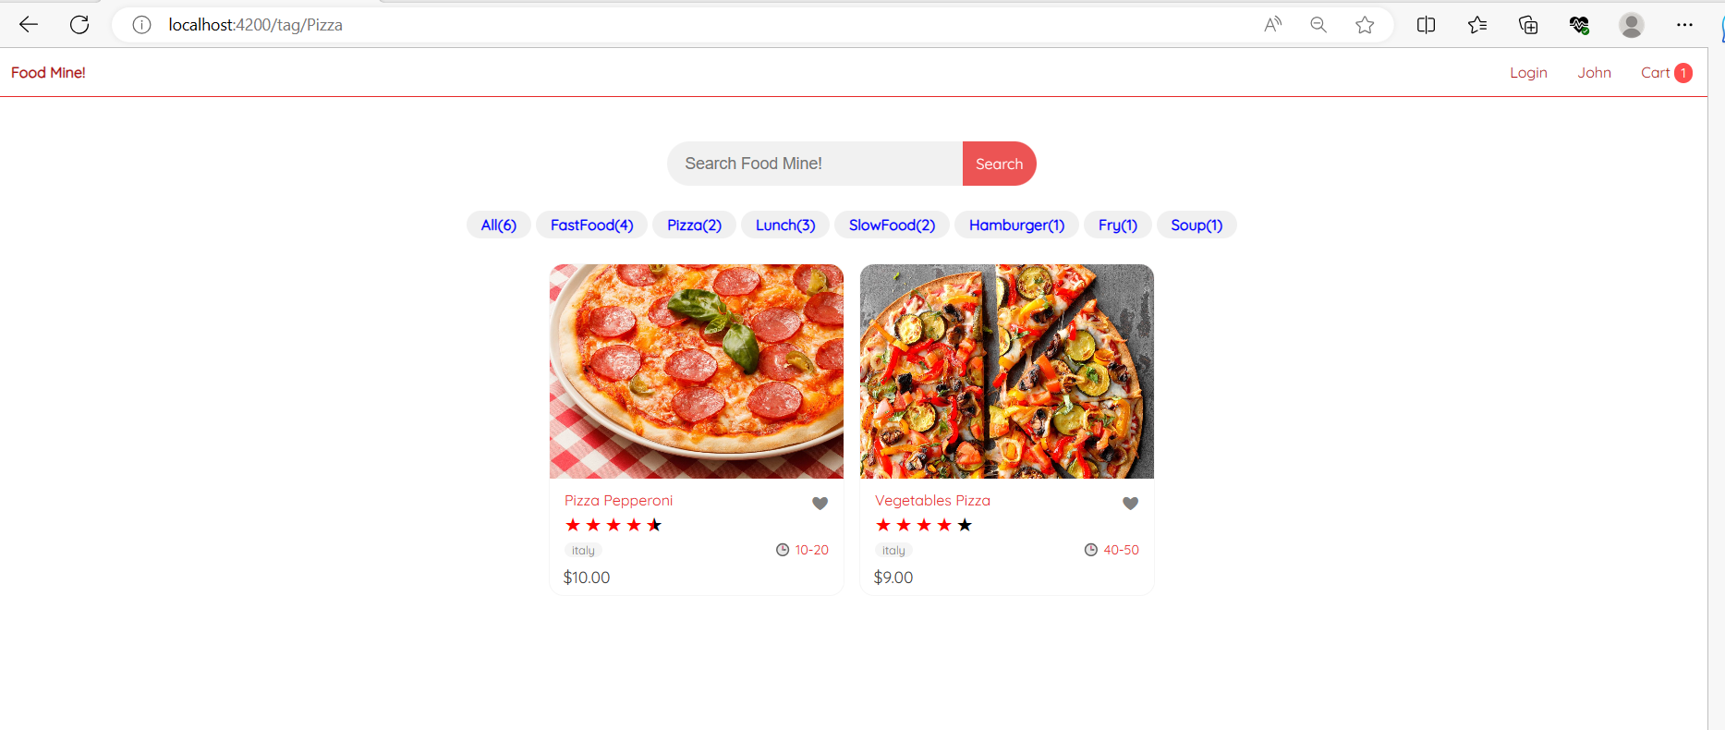

* If you clicked on Lunch, it will show you below page

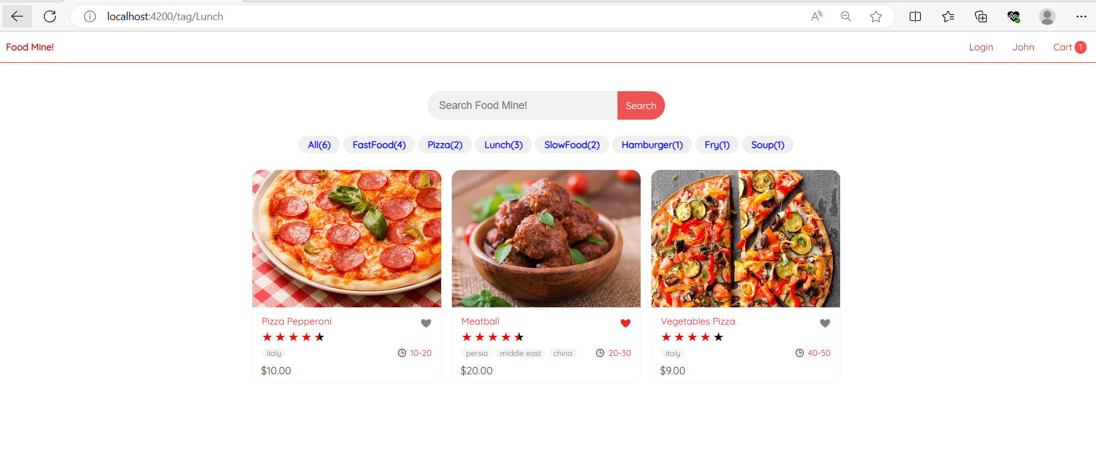

* If you clicked on Slow food, it will show you below page

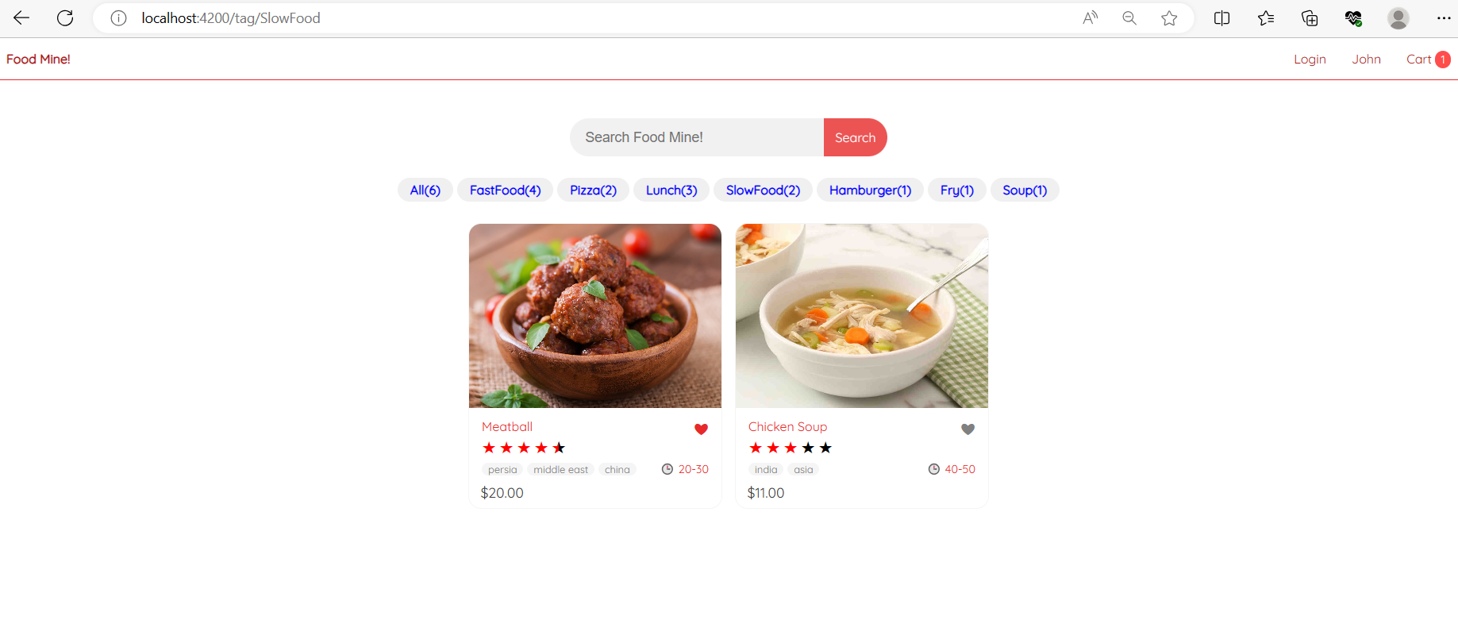

* If you clicked on Hamburger, it will show you below page

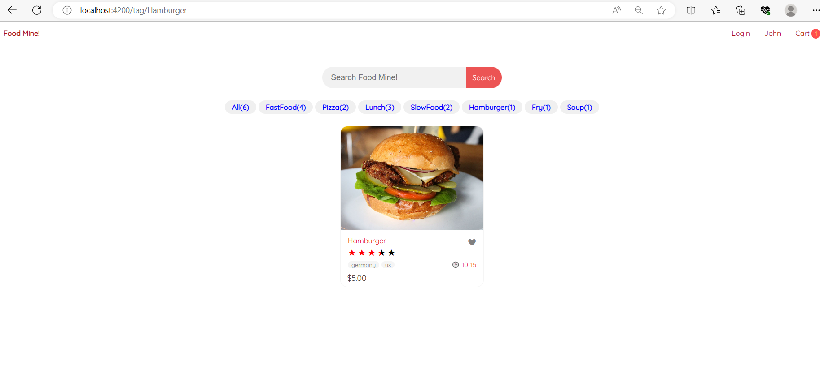

* If you clicked on Fry, it will show you below page



* If you clicked on Soup, it will show you below page

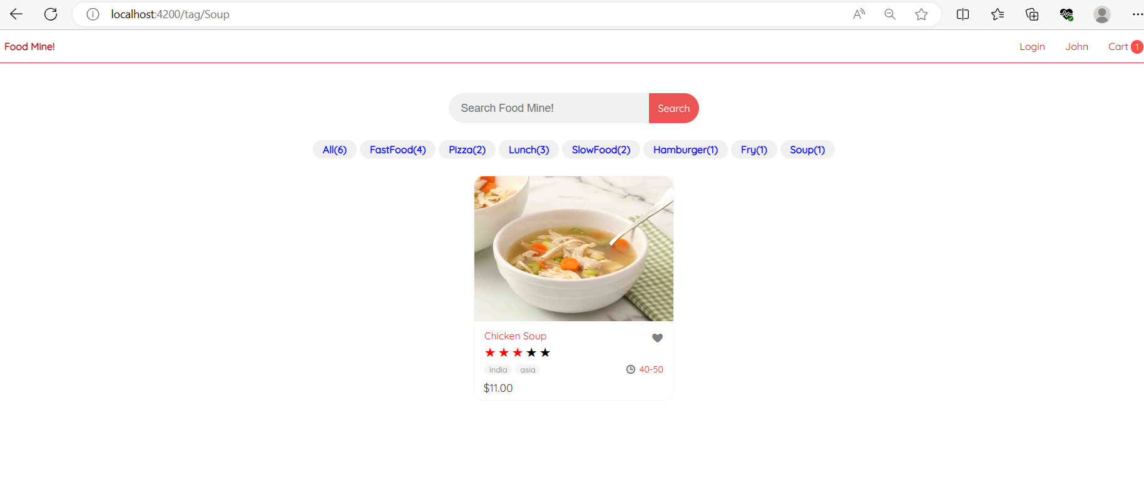

* Search option available to search the food by typing the name.

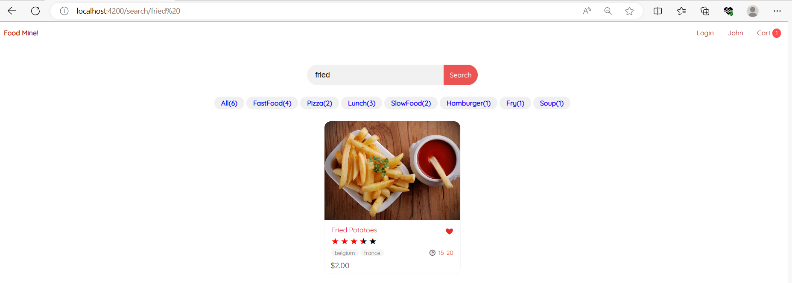

* You can select food by clicking on picture of your favourite food. Here food name and food price shown as well button for add your food into the card.

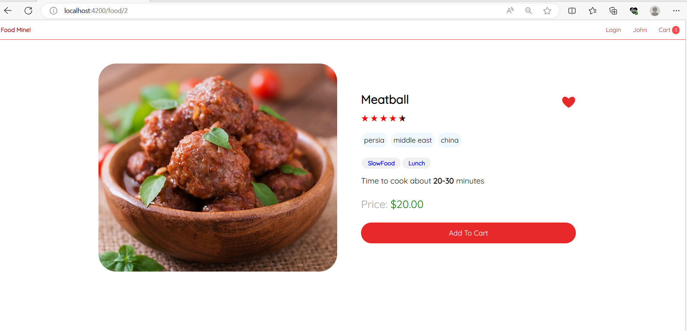

* If you clicked on add to card button, your food will add into the card. Will show current food added into card with total price.

